APPENDIX E. PROPOSAL TEMPLATE FOR PRODUCTION TEST

Table of Contents (Heading Style 1 – no TOC)
List of Acronyms (if it is not its own annex) ii
Executive Summary (TNR, 12pt, White, bold, all caps) Heading 1 1
I. Alternative heading 1 style when numbering is used (numbered heading 1) 1
Heading Level 1, White on Teal, All Caps, Bold 1
Heading Level 2, Teal, Small Caps, Bold 1
Heading Level 3, Teal, Small Caps 1
Goals and Objective of the Program (Heading 2) 1
Heading Level 3 1

ANNEXES (bold, 12pt, TNR)
A. Annex 1 title

List of Acronyms (if it is not its own annex)
WFP World Food Programme

Executive Summary (TNR, 12pt, White, bold, all caps) Heading 1

- Alternative heading 1 style when numbering is used (numbered heading 1)

Heading Level 1, White on Teal, All Caps, Bold

Heading Level 2, Teal, Small Caps, Bold
Title Text Box, Arial 9 Bold, centered, (Text Box Title Style)
Keep a space in between txt box title and regular 9pt text. (Table and Box Text Style)
Background: RGB 198/230/232

Heading Level 3, Teal, Small Caps

Heading Level 4, Dark Grey, Bold Italic

Heading Level 5, Dark Grey, Bold

Goals and Objective of the Program (Heading 2)

Heading Level 3
Basic sample text, TNR 11, left aligned, 6pt paragraph spacing (after).
Lorem ipsum dolor sit amet, consectetur adipiscing elit. Sed eu arcu sed lacus rutrum tempor. Nullam nec condimentum purus, id laoreet neque. Aliquam vehicula velit nec convallis blandit. Nunc sem felis, faucibus sit amet efficitur nec, finibus non tortor.
Aenean scelerisque dignissim rutrum. In at felis justo. Curabitur placerat id tortor nec posuere. Duis aliquet sapien at dignissim luctus. Aenean luctus rutrum ligula, sed laoreet diam. Morbi vel accumsan lectus. Etiam urna lorem, mollis et placerat et, porttitor a nisl. Aenean rhoncus vehicula quam, interdum bibendum magna ultricies id.
Figure X. Arial, 9ptont, bold, Dark Gray (RGB #79, 78, 86) left aligned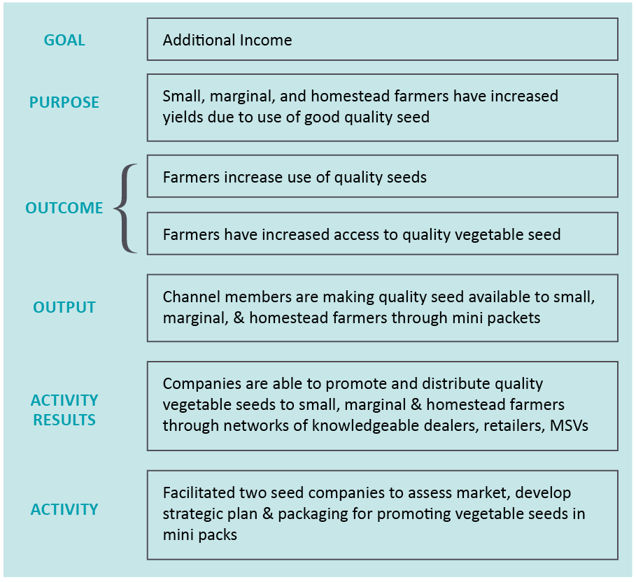

Aenean ut porttitor orci. Morbi ac maximus augue. Etiam cursus semper justo sed vulputate. Nulla cursus lorem a fringilla eleifend. Vestibulum tincidunt rutrum suscipit. Fusce dignissim mi at turpis fringilla lacinia. Cras ultricies rutrum sodales. Integer a orci fringilla, rhoncus sapien id, semper elit. Suspendisse potenti.
Praesent accumsan at nisi vitae iaculis. Pellentesque at erat leo. Ut vel rutrum metus. Quisque vestibulum arcu id risus dapibus dignissim. Quisque eleifend justo ac lacus hendrerit, a varius elit mollis. Nullam
Figure X. Arial, 10pt font, bold, Dark Gray (RGB #79, 78, 86)
Column Heading, Arial 9, RGB #0, 155, 167 | Column Heading Arial 9 (Table Header Row Style)
Text Arial, 9, (RGB# 209, 208, 209) | (Table and Box Text Style)
Left align text and numbers | Make sure to use commas for thousands (1,222)
Cell Margins: Top/Bottom .02”, Left/Right .05”

Outline Guide

Red Font: Indicate solicitation instructions, program description or statement of work presented in the solicitation.
Red Font (italicized): Indicate solicitation evaluation criteria.
Green Font: These are notes from BDG regarding the section and may include notes as to why something is included or moved.

Annex 1
Title of Annex

Annex A: Title of Annex
Text……
Insert page break if annex text continues (page numbers should continue)
If next page is a divider, insert section break (then unlink footers and headers and remove page number)
Page number for each new annex starts at 1 on the annex title page

