Contents
Executive Summary 2
1. Descriptions of oUr Activities and Objectives 2
2. Project Implamentation 2
3. Monitoring * EvaLuations 4

Executive Summary
The [DONOR]-[PROJECT TITLE] (hereinafter: Activity or PT) aims to sustainably improve the economic well-being for farmers, people, youth, and women involved in agriculture markets in Tajikistan by facilitating increases to market access, productivity, and access to finance, as well. The Activity will also mainstream gender and youth while supporting adoption of climate smart agriculture. This report covers Quarter II (2) during the first year of implementation.

Descriptions of oUr Activities and Objectives
The PT Activity is a nationwide 5-year program to foster growth in agriculture market system in Tajikistan. It will select a handful of agriculture sectors and identify key constraints and opportunities, design and implement interventions to stimulate innovation and market transformation by partnering with the private sector and leveraging their investment. PT will build on experiences of other [DONOR] programs in Tajikistan to ensure synergies and/or continuity of development support to a positive adjective agriculture sector in the country. The goal of the Activity is to accelerate the growth of Turkmenistan’s agriculture sector and sustainably improve the economic well-being for the farmers women and youth while promoting increasing climate resilience in the farming households. To achieve that, the Activity focuses on three objectives:
In FY23 QII alongside project start-up activities, the Activity developed and submitted several start-up analyses per the approved Work Plan, namely the:
- Inclusive Market Systems Analysis
- Gender Youth, and Social Inclusion (GYSI) Analysis
- Climate Risk and Opportunities Assessment

- Objective 1: Increased investment in the agriculture sector: $15 million in private sector investment ,
- Objective 2: Improved value chain productivity: 500 Small and Medium Enterprises (SMEs) strengthened, and
- Objective 3: Greater access to profitable markets: $30 million in domestic and export sales.
- Cross-Cutting Objectives
- Promoting economic participation and well-being of women and youth in Tajikistan Agriculture markets: 40 percent and 30 percent of the Activity participants are women and youth respectively
- Promoting climate smart agriculture practices: 1200 metric tons of carbon dioxide (CO2) equivalent, reduced, sequestered, or avoided.

Project Implamentation
Based on the approved startup workplan for the period October 2022 to March 2023, the Activity remains largely on track in completing those very important required deliverables. Quay assessments completed include Inclusive Market Systems, Gender, Youth, and Social Inclusion (GYSI) Analysis and Climate Risks and Opportunities Assessment are complete, and the Activity is now drafting the findings. On the Political Economy Analysis, there had been a challenge in finding the right resources to conduct the assignment which resulted in a small series of unforunatey and unexpected delay, but now this has been resolved now and PT remains on track to complete the analysis before end of Year 1. There was an issue with finding the appropriate resources to do the Political Economy Analysis, which caused a slight series of unplanned and unforeseen setback, but this has been fixed now and PT is still on track to finish the analysis before the end of Year 1.The Private Sector and Financial Landscape Analysis is also due for completion by end of April of 2022 as initially planned. Two partnerships have already been forged through MOU with agriculture private sector players in line with PT’s outcome. In the coming months, the TP activity will be going to the market to solicit proposals from prospective partners to deepen its implementation and engagement in the agriculture market systems. PT has also been very active in stakeholder engagement and coordination, reaching out to relevant development organizations and projects, with the ambition of increasing synergies and avoiding duplication. This will remain an ongoing priority throughout the Activity’s period of performance. Listed below is a more elaborate list of description of PT achievements through the end of Quarter three. 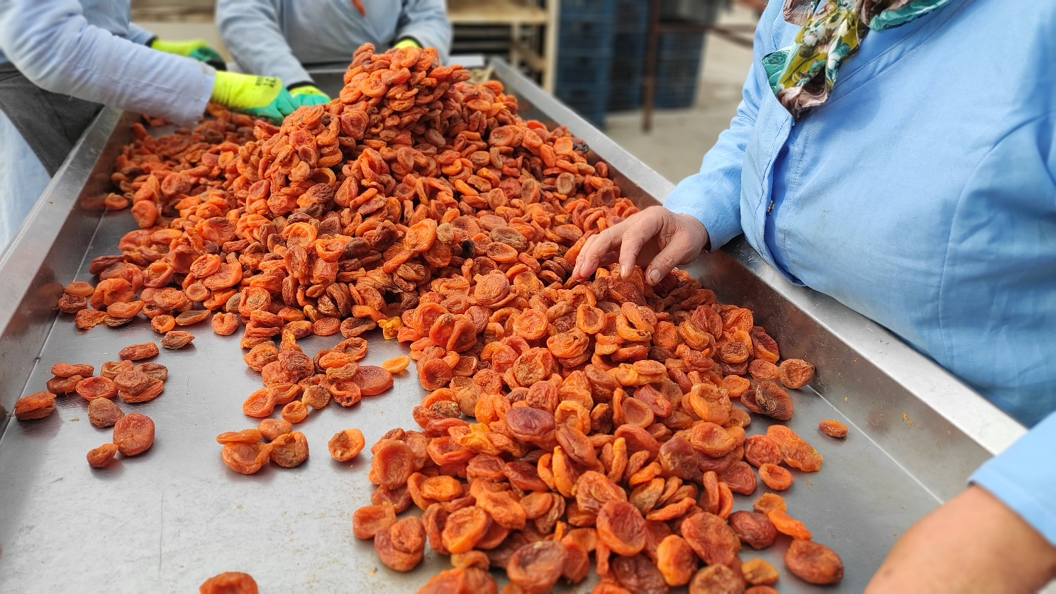
Image 1 – Workers processing dried apricots.

Table 1:
Operational Task |  | Statuses and their Updates
1. Establish the PT Activity registration, accounts, office site selection, and set up. |  | Completed.
2. Recruit a lean team with the aim to be fully staffed by the end of this work plan period. |  | Completed. 1 position out of eighteen remains open. All four key personnel have been hired.
3. Developed relevant operational procedures and manuals for the Activity, prioritizing travel, finance, security, procurement, and employee policy manuals. |  | Completed. Employee Policy Manual is currently being vetted by local legal firm to ensure full compliance with local regulations. Project team is keenly aware of how important this is.
4. Install and/or installed required software and established petty cash procedures. |  | Completed.
5. Complete procurement for legal representation, office set up, and IT services. |  | Completed
6. Conduct onboarding and training (e.g., accounting, human resource policies and procedures/timesheet management, subaward and procurement, ethics training, market  systems training, etc.) of all hired activity staff, utilizing Home Office support |  | Mandatory trainings are completed. Additional trainings are planned for April utilizing Home Office support
7. Submit branding strategy and marking plan. The official launch of the Activity is planned for May 2023 to ensure completion of assessment and strategy and also to promote increased coverage among stakeholder participation |  | Completed. Lunch expected slated for the first part of May as initially planned
8. Develop Market Partnership fund manual and train the staff no procedures and compliance. The call for action is expected to be published towards the end of six-month work plan period. | Market Partnership fund approved. Training and call for action expected to be published by April 2023.
Technical Task | Status
1. Inclusive Market Systems Analysis |  | Completed and submitted to [DONOR].
2. Private Sector Engagement (PSE) Mapping |  | Initiated. To be completed by April 2023
3. Gender, Youth, and Social Inclusion (GYSI) analysis |  | Completed and submitted to [DONOR].
3. Climate Risks and Opportunities Assessment (CROA) |  | Completed and submitted to [DONOR].
4. Activity Monitoring, Evaluation, and Learning Plan (AMELP) with updated and revised indicators. |  | Completed and approved by [DONOR].
5. Political Economy Analysis (PEA) |  | PT is working with an international consultant to carry out the PEA before the end of the fiscal year.
6. Under Outcomes 1, 2 and 3, identify and prioritize quick wins. Several options have been discussed in the work plan. The Activity will shortlist and initiate a select number of partnerships with the private sector. |  | Deferred until roll out of the call for action (CFA) and annual program statement (APS). Using implementer and volunteer resources, two partnerships have been initiated.
7. Assess and identify possible volunteer opportunities/assignments as part of the Activity’s market scoping, with the aim of initiating volunteer programs following the first six months. |  | First volunteer mobilized in late March.

Monitoring * EvaLuations
During this reporting period, the MandE team is fully staffed and trained on ACDI/VOCAs Monitoring, Evaluation, and Learning (MEL) Framework and Learning, Evaluation, and Analysis Platform (LEAP) system. Furthermore, the M&E team developed a dataflow of the activity and indicators data requirements, which will help to establish the activity data collection tools and database for tracking the activity performance.
In addition, all new technical staff oriented in the M&E system, indicators, and targets jointly with HO Director, Monitoring, Evaluation, and Learning. At the same time, the CLA concept was introduced to the team to develop the Collaboration, Learning, and Alarming (CLA) questions and plan.
As part of the Market system assessment, and using the primary interviews, focus group discussion, and stakeholders’ validation workshops, the M&E team assisted the technical team in collecting data for the sector screening and assessments to identify and select the sectors for Activity intervention. A total of 39 interviews were conducted with different value chain actors during the second phase.
Table 3 presents information on the number of data collection activities conducted with value chain actors during this period:
Table : Number of Value Chain (VC) actors one of one interview
Value chain actors | ^{Second} phase | Comment
Producer | 18 | The 2nd phase assessment covered interviews in [TOWN] and [DISTRICTS]. A total of 12 women and 27 men among all Value Chain actors were interviewed.
Exporter/ processor | 9
Worker | 5
Aggregator | 5
Input Supplier | 1
Transport company | 1
Total | 39

Stakeholders’ validation workshops conducted by the value chain sectors: Vegetables, Fruits, Special crops, and Dairy. A total of 81 value chain actors participated in these workshops:
Table 4: Participants of stakeholders’ validation workshops
Value chain actors | Female |  |  | Male |  |  | Grand Total
 | 15-29 | 30+ | Total | 15-29 | 30+ | Total
Civil Society | N/A | - | N/A | 0 | 9 | 9 | 9
government | 0 | 0 | 0 | 0 | 8 | 8 | 8
private sector | 1 | 8 | 9 | 5 | 38 | 43 | 52
Producer | 0 | 0 | 0 | 0 | 3 | 3 | 3
Worker | 0 | 1 | 1 | 2 | 6 | 8 | 9
Grand Total | 1 | 10 | 11 | 7 | 64 | 71 | 83

As part of the project's grant system, the MEL team developed a concept note template for each proposed activity, and the results chain should supplement each concept note. Results chains lay out the technical team's assumptions regarding the effects of the activity they implement. A results chain gives the understanding of how the proposed activity leads to outputs and outcomes and, in general, shows the impact. It also helps to see the contribution of each indicator and what type of information should be collected in each stage. A results chain shows how the planned activity produces outputs and outcomes and, overall, shows the effect. It also helps to understand the role of each indicator and what kind of information should be gathered in each stage. A results chain is like a domino effect, where the action leads to results and impacts, and shows the whole picture. It also helps to see how each signpost measures progress and what kind of clues should be collected at each step. Revise to make concise.

