Annex to Engineering Drawings of the Portable Shallow-Bed Batch Maize Dryer R0

AflaSTOP: Storage and Drying
For Aflatoxin Prevention

January 2017

Prepared by:
Marius C. Rossouw
Dryer Technology Pilot Manager
AflaSTOP
mrossouw@asintl.org

Prepared by:
Marius Rossouw
Dryer Technology Pilot Manager
mrossouw@asintl.org

REPORT

Demonstration Construction and
Training for Formal and Informal (Artisan) Fabricators of the EasyDry M500

AflaSTOP: Storage and Drying
For Aflatoxin Prevention

July 2015

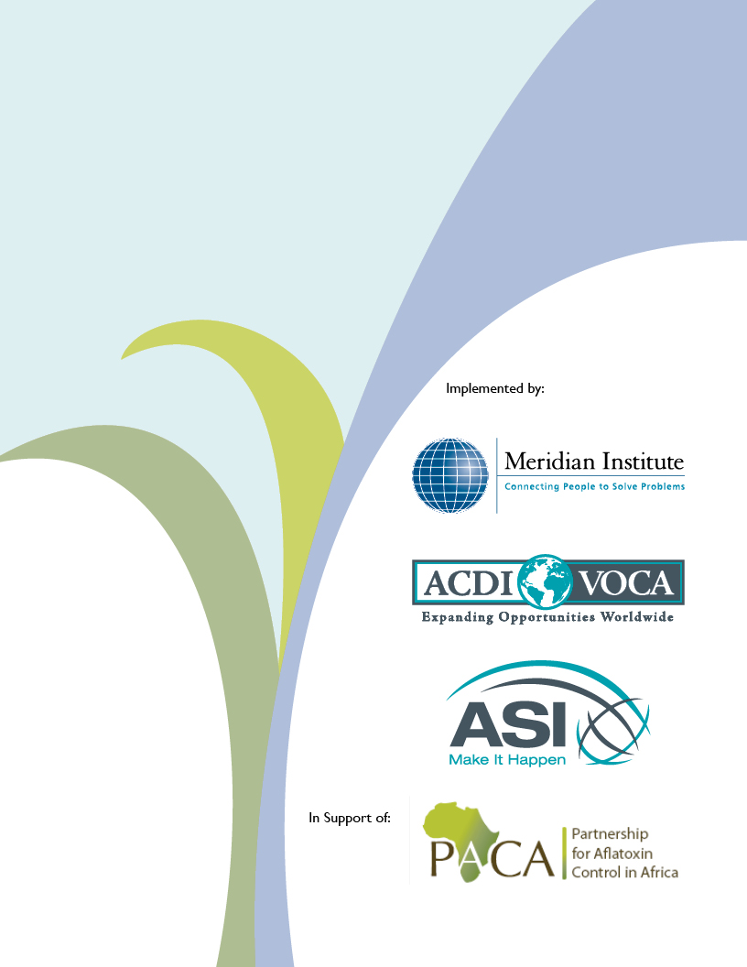
TABLE OF CONTENTS
1 Background 4
2 Size Increase of Transportation Handle Support Members 4
3 Addition of a Furnace Rain Cover 4
4 Addition of a Chimney Latch System 5
5 Addition of Vibration Supports to the Primary Fan. 6
6 Addition of Heat Shields for the Canvas Plenum Connection 6
7 Heat Exchanger Modification 7
8 Conclusion 10

LIST OF FIGURES
Figure 1: Size increase of transportation handle support members 4
Figure 2: 18-Gauge furnace rain cover 5
Figure 3: Chimney latch system 5
Figure 4: Fan blade metal fatigue 6
Figure 5: Fan blades with vibration dampening supports 6
Figure 6: Cotton canvas plenum connection burnout 7
Figure 7: Plenum connection internal and external heat shields 7
Figure 8: HX burned out after 10 days of fire exposure 8

LIST OF TABLES
Table 1: Angle iron and flat bar HX protection fabrication details 8

Background

AflaSTOP deployed the Portable Shallow-Bed Batch Dryer in the predominantly maize growing areas of Turbo and Kapseret of Uasin Gishu, Kenya from October to December 2016 to better understand its usability and the durability of materials selected for the construction. The dryer was exposed to one harvest season’s predicted workload (40 x 9 hour works days) and all problems identified and addressed. Below follows a breakdown of the required design changes that should be incorporated when referencing the “Engineering Drawings of the Portable Shallow-Bed Batch Maize Dryer” dated March 2016 when constructing the now called EasyDry M500 (M for maize and 500 for the 500 kg batch capacity) to ensure a hassle-free and low maintenance portable maize dryer.

Size Increase of Transportation Handle Support Members
(605-ASI-003 - DRYER UNIT RIGHT COVER ASSEMBLY and 605-ASI-002 - DRYER UNIT LEFT COVER ASSEMBLY)

Design change justification

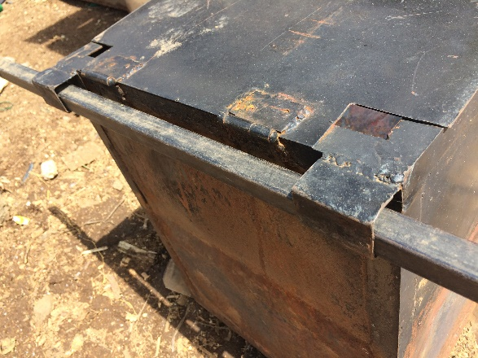
Transporting the EasyDry M500 by hand requires (2) ¾”x ¾” x 40” square tubes that slots into 1”x 1” x 2” square tubes welded to the dryer body. These transportation handles are often used to stoke the fire as well as level the maize bed after loading. Some operators also use these handles to force the final few burning cobs through the fire grate in order to move the dryer away from the ash for it to cool down. All of these actions deform the ends of these handles just enough to become cumbersome when inserting them into the transportation handle support members. It was therefore decided to increase the size of these support members from 1” square tubing to 1 ¼” square tube where the additional ¼” clearance allows for a slightly deformed handle to still enter without effort.
Figure 1: Size increase of transportation handle support members

Design change fabrication details

The following material is required to replace the current transportation handle support members:

- (4) 1 ¼”x 1 ¼” x 1/16” x 2” Long square tube.

Replace the original 1”x 1” x 1/6” x 2” with the new 1 ¼”x 1 ¼” x 1/16” x 2” square tubes on both sides of the dryer body.

Addition of a Furnace Rain Cover
(604-ASI-001 - DRYING AIR BODY SUB-SUBASSEMBLY)

Design change justification

Operating the EasyDry M500 during heavy rain highlighted a concern with rain cooling the furnace fire and slowing the drying operation down. Simply closing the furnace opening completely was not an option since all of the combustion air is supplied from the top. The addition of an appropriately sized foldable rain cover that would shield the fire in the event of rain was added to the furnace opening. Even though the cover did not cover the furnace opening completely, it worked sufficiently well since any rain that made it into the furnace connected with the heated furnace plate and evaporated before reaching the fire. Note that the furnace rain cover should only be used during pouring rain and stowed away next to the furnace body when not in use.

Design change fabrication details

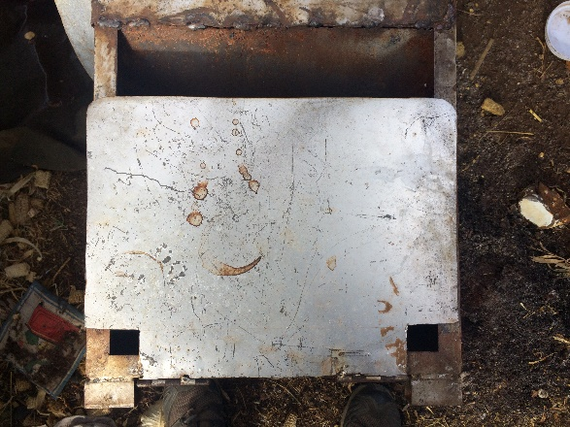
The following material is required to fabricate the furnace rain cover:

- (1) 16” Wide x 10” long 18-guage mild steel sheet notched 2 ½”x 2”to clear the transportation handles;
- (2) 2” Door hinges

Notch the 16” wide x 10” long 18-gauge sheet metal to clear the transportation handles once in place. Hem the sheet metal (¼”) on the opposite end to provide rigidity and structural integrity. Weld the small door hinges to the top of the furnace frame and to an 18-gauge mild steel sheet.
Figure 2: 18-Gauge furnace rain cover

Addition of a Chimney Latch System
(605-ASI-004 - DRYER UNIT CHIMNEY ASSEMBLY)

Design change justification

The original design relied on the chimney’s self-weight to keep it upright during operation once erected. This design worked well until a short operator attempted to remove the cob drying basket when the chimney collapsed as the basket legs got caught and pulled the chimney over. This issue could potentially cause injury and required a mechanism to lock the chimney in place during operation. A simple latch system was added to keep the chimney locked in place. The following material was required:

Design change fabrication details

The following material is required to fabricate the chimney latch mechanism:

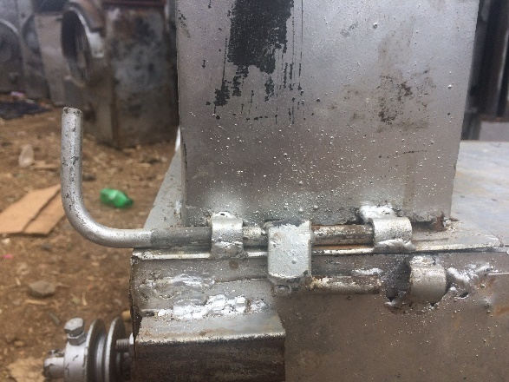
- (1) 3/8” x 8” Long round bar
- (1) 3/8” x 2” Long round bar
- (1) ¾” x 1/8” x 1 ½” Long flat bar
- (3) ¾” Diameter x 1” long pipe

Bend a 2” section of the 3/8” x 8” long round bar at 90⁰. Weld the one end of the ¾” x 1/8” x 1 ½” long flat bar to the 6” section of the 3/8” x 8” long round bar and the other end to the 3/8” x 2” long round bar. Add 2 of the ¾” diameter x 1” long pipes on both ends and weld the pipes to the chimney support frame. Weld the receiving ½” diameter x 1” long pipe to the main dryer body, ensuring that the top latch section interlocks with the bottom in a tight fit.
Figure 3: Chimney latch system

Addition of Vibration Supports to the Primary Fan.
(604-ASI-002 - 18 IN PRIMARY FAN ASSEMBLY)

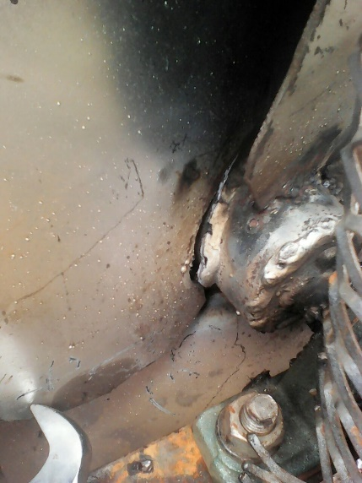
Design change justification

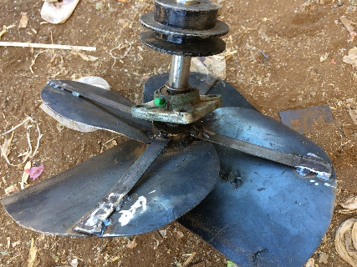
Four days into running the dryer for consecutive days saw fatigue cracking develop where the 14-guage primary fan blades were welded to the hub. The problem was that the size of the primary fan blades vs. the welded surface area to the hub were such that they tend to vibrate during operation. This vibration caused metal fatigue just above the welds as this was where the blades are constrained and will tend to break. This problem was only observed with the big 450 mm fan and the required design change therefore only applied to this fan. The easiest and cost effective solution was to reinforce the fan blades by adding vibration dampening supports at the back sides of the blades welded to the hub. The modified fan was operated for 360 hours and inspected with no signs of fatigue due to fan blade vibrations.
Figure 4: Fan blade metal fatigue

Design change fabrication details

The following material was required:

- (4) 3/4” x 1/8” x 7.5” Long flat bars

Weld the 3/4” x 1/8” x 7.5” long flat bars to the flat outer edge on the back end of each blade and flush with the back end of the hub. It is important to add the vibration dampening supports at 90⁰ angles to avoid an imbalance.
Figure 5: Fan blades with vibration dampening supports

Addition of Heat Shields for the Canvas Plenum Connection
603-ASI-002 - REMOVABLE HEAT EXCHANGER (HX) PANEL

Design change justification

Five days into operating the dryer highlighted a material selection concern with the connection between the plenum and the dryer body. Initial literature sited when the material was selected rated the cotton canvas used as having a working temperature of 400 ⁰C (much higher that experienced at the duct connection). This information was not reliable as some inferior canvas produced in Asia has made its way in East Africa and was sourced by the local fabricator. It was therefore required to devise a solution to reduce the temperature experienced at the duct connection that allows this material to be as no alternative affordable and flexible material was readily available in East Africa.

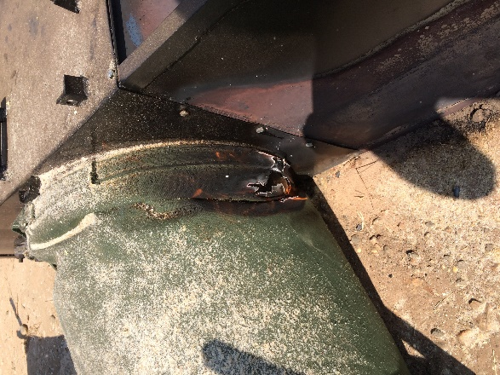
It was important to shield the cotton canvas from the heat exposure both from the external and internal surfaces. The drying air had a cooling effect on the canvas beyond the 3” connecting scroll which only required the solution to deal with excess temperature due to convection heat transfer through the connecting 3” metal scroll. External and internal heat shields were added to the connection scroll and the problem was solved with the plenum withstanding the heat exposure for the duration of operations to follow.

Design change fabrication details

The following material is required to fabricate the plenum heat shield:

- (1) 3 ¼” x 12” Long 18-gauge mild steel sheet;
- (1) 7” Wide x 12” long strip of raw leather;
- (1) 3” x 12” 32-Gauge galvanized sheet metal strip;
Figure 6: Cotton canvas plenum connection burnout
- (6) 5mm Blind rivets;
- (12) Washers to fit the blind rivets.

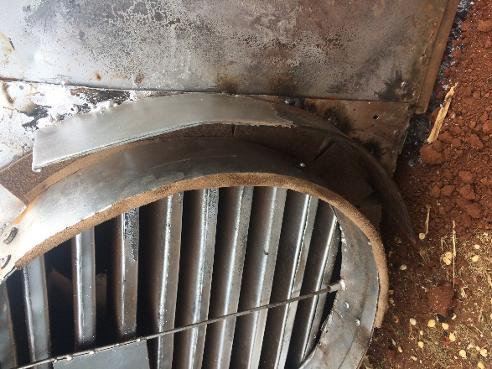
Hem the 3 ¼” x 12” long 18-gauge mild steel sheet on 3 sides and stich weld it in an annulus configuration 2” offset from the duct connection scroll. Ensure that it reaches far enough in both directions to protect the canvas connection fully from the external furnace body radiation.

Fold the 7” wide x 12” long strip of raw leather in half lengthwise and sandwich it between the original duct connecting scroll and the galvanized sheet metal. Once sandwiched, drill 6 x 6mm holes through all the material and rivet the 3” x 12” 32-Gauge galvanized sheet metal strip in place by placing washers on either ends to increase the surface area holding the sheet metal in place. Pin the leather at the bottom side only by passing the rivets through it, leaving the top to contract in case of shrinkage. This ensures that protection is provided where needed most, closest to the furnace. Trim any excess leather in contact with the furnace body ensuring that it does not make significant contact with the main dryer body as it could combust and damage the plenum connection.
Figure 7: Plenum connection internal and external heat shields

Heat Exchanger Modification
(603-ASI-003 - REMOVABLE HEAT EXCHANGER (HX))

Design change justification

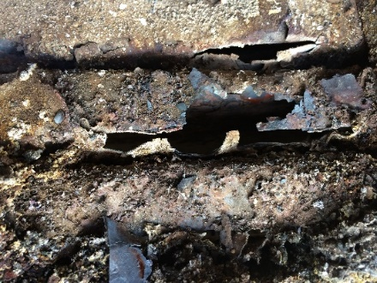
Close attention was paid to the heat exchanger (HX) and how it would hold up to the high temperatures. Experts were approached for input during the initial design process with the conclusion that locally available material should be used and inspected to see how it held up to one season’s heat exposure requirements. It was soon clear that a possible combination of heat cycling and corrosive gasses was compromising the integrity and shortening the lifespan of the 18-gauge mild steel sheet metal originally selected. The interface where the HX was exposed to the extreme heat from the furnace burned out within 10 days of operation. This was not acceptable since the cost and downtime required to replace the HX mid-season would compromise the dryer’s business viability.

It was important to devise a solution in line with the original design principles of local manufacturability. This meant finding a way to protect the thin HX panels at the furnace interface using affordable, locally available material. Research and expert opinions recommended the following options being tested over a representative amount of time, burning the dryers as if they were servicing clients and evaluating the impact the various solutions had on the HX’s durability. The following interventions were proposed and tested:
Figure 8: HX burned out after 10 days of fire exposure

- Painting the HX at the furnace interface with locally available heat resistant paint;
- Protecting the HX panels by placing them in mild steel angle and flat bar configured channels at the furnace interface;
- Replacing the entire mild steel HX with Stainless Steel;
- Protecting the HX panels by facing them with a Stainless Steel faceplate.

Each proposed solution was tested with mild steel angle and flat bar configured channels selected due to its cost and the local availability of material. The HX protection solution was fired for 40 days and inspected every 10 days with no significant deterioration of the angle irons or flat bars noticed.

Design change fabrication details

Below follows the required material and fabrication details for this angle iron and flat bar HX protection:

- (1) 1” x 1” x 3/16” x 9 ½” Long angle iron notched on both ends to make 8” internal dimension;
- (9) 1 ¼” x 1 ¼” x 3/16” x 9 ½” Long angle iron;
- (9) 1 ½” x 3/16” x 9 ½” Long flat bar;
- (18) ½” x ½” x ¾” Long square bar;
- (2) 11 ¼” x 24” Long 18-gauge mild steel sheet metal notched to allow for 2” and ¾” bends;
- (18) 11 ¼” x 21 ¾” 18-Gauge mild steel sheet metal notched to allow for 1” and ¾” bends;

Table 1: Angle iron and flat bar HX protection fabrication details
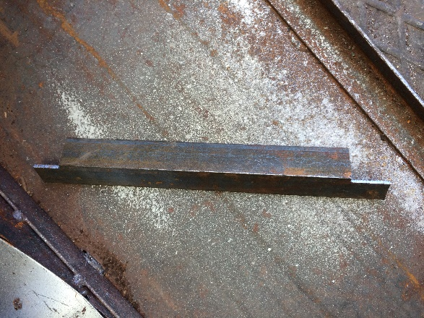  Step 1: Cut the 1” x 1” x 3/16” x 9 ½” and nothch the in such a way that it 1will fit flush inside the HX/Furnace opening, about 8” wide. | 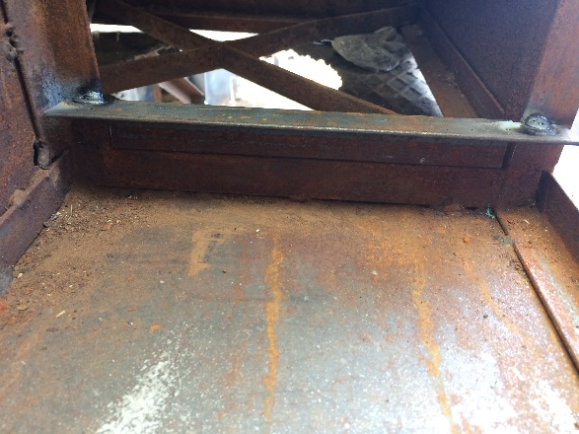  Step 2: Weld the 1” x 1” x 3/16” x 9 ½” long angle iron flush facing inwards to the furnace body at the bottom of the Furnace connection.
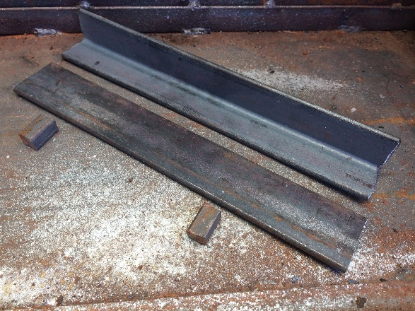  Step 3: Cut the 1 ¼” x 1 ¼” x 3/16” x 9 ½” angle iron, 1 ½” x 3/16” x 9 ½” flat bar and (2) ½” x ½” x ¾” square bars. | 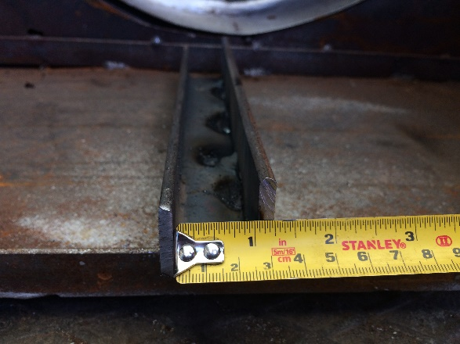  Step 4: Create a 1 ¼” high x 9 ½” long channel by stich welding the flat bar to the angle irons so that the internal channel opening is about 1” high.
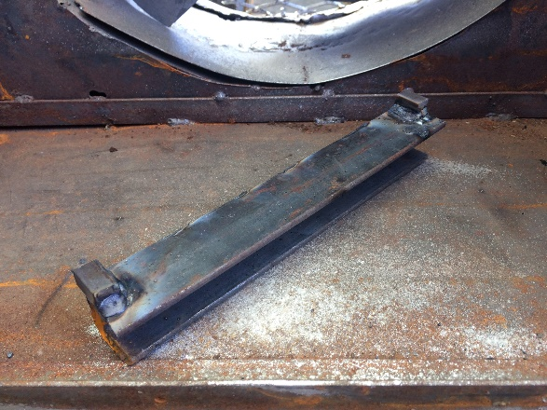  Step 5: Weld the (2) ½” x ½” x ¾” long square bars to the outer edges of the flat bar side of the channel created in Step 4. These will serve as spacers to ensure that a ½” gap remains between channels when they are stacked together and welded to the furnace body. | 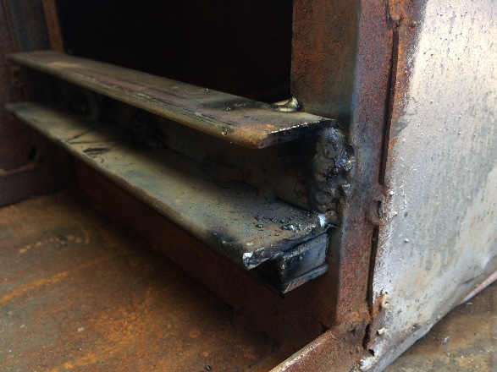  Step 6: Place the channel with the square bar facing down on top of the bottom angle iron and weld it 1/8” offset from the outer edge of the dryer body only, leaving a ¼” gap on the inside for the channel to expand lengthwise due to heat exposure.
Step 7: Repeat Steps 3 to 6 and weld the remaining 8 channels one on top of the other, ensuring a ½ “gap between the top of the first channel and the bottom of the next.  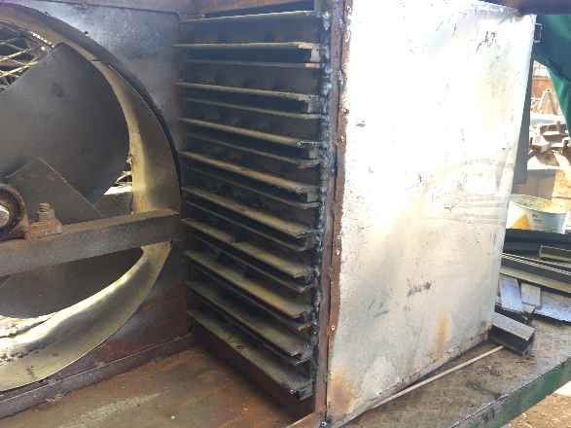 | 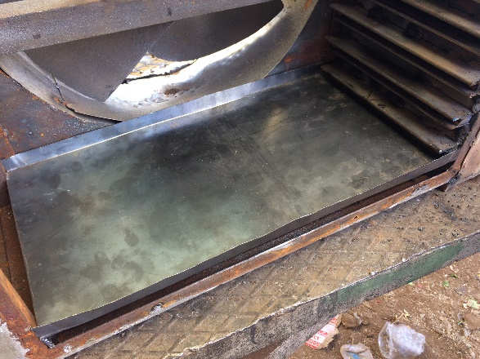  Step 8: Measure the HX cavity and cut and bend all HX panels accordingly. Place the bottom panel into the HX cavity under the angle iron and ensure that all sides are in tight contact with the dryer body and protecting channels.
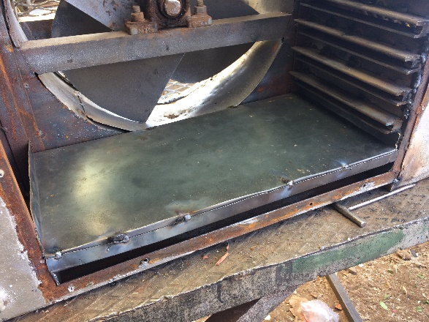  Step 9: Place and tack weld the first internal HX panel inside the bottom HX panel and angle iron channel and ensure that all sides are in tight contact with the bottom panel and the dryer body. Note that long edges of the HX panel required lengthening from the original ½” to ¾” to accommodate for the ¼” increase of the angle iron and flat bar thickness. | Step 10: Repeat Step 9 for all the reaming internal HX panels ensuring that all sides are in tight contact with the panel below them, the dryer body and the protective angle iron and flat bar channels.  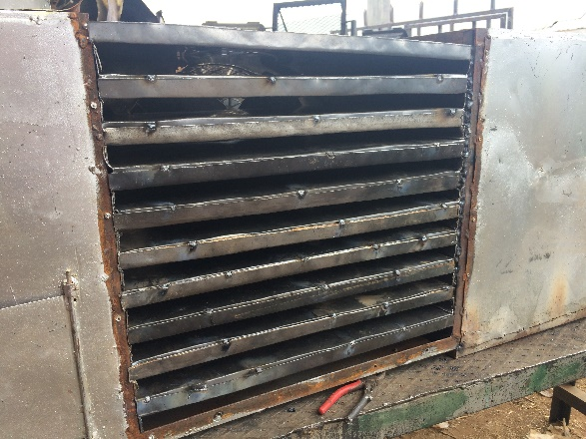
Step 11: Place the top HX panel and cut to size.  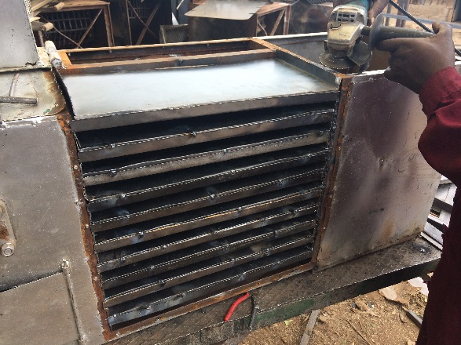 | 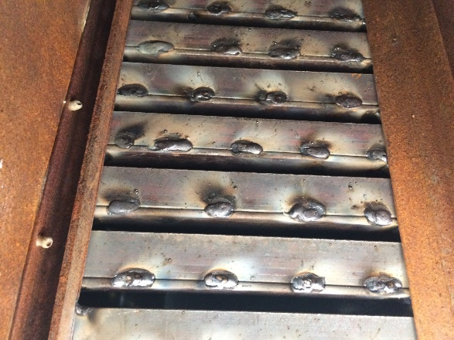  Internal view of the HX protection:

Conclusion
40 Days of continuous daily operation of the Portable Shallow-Bed Batch Dryer highlighted some usability and material durability issues that required design changes in order to ease usability and minimize maintenance during the harvest season. The following design changes were made resulting in the next generation maize dryer also known as the EasyDry 500:

- Increasing the transportation handle support member sizing from 1” to 1 ¼” square tube;
- Adding a 16” x 10” 18-gauge mild steel sheet metal finance rain cover;
- Adding a chimney latch system;
- Adding vibration supports to the primary fan;
- Adding heat shields for the canvas plenum connection;
- Adding angle iron and flat bar protective heat exchanger channels.

